**Project Proposal for Database Course**

**Project Title:**

Factory Management System (FMS)

**Project Team Members:**

• Abdul Ahad (22K-4353)

• Affan Hassan (22K-4445)

* **Introduction:**

In the modern manufacturing industry, efficient factory management is critical to optimizing production,  reducing waste, and ensuring timely deliveries. This project aims to develop a **Factory Management  System (FMS)** that will streamline key factory operations such as inventory control, employee  management, production scheduling, and quality assurance.

The FMS will be designed to provide real-time visibility into factory operations and facilitate data-driven  decision-making. It will enhance operational efficiency by automating various manual tasks and offering  detailed reports and analytics.

* **Objectives:**
* The primary objectives of the **Factory Management System** include:
* Automating factory operations such as production planning, inventory management, and  employee scheduling.
* Ensuring the factory’s resources (raw materials, labor, machines) are optimally used.
* Providing real-time tracking of production progress and inventory levels.
* Supporting decision-making through analytics and reporting on production efficiency, resource  usage, and cost optimization.
* Enhancing communication and coordination between different departments such as  procurement, production, and quality control.
* **Functionalities:**

The **Factory Management System** will include the following key functionalities:

1. **Dashboard:**

* Overview of factory operations with real-time data.
* Display of critical KPIs such as production rates, inventory levels, and employee  attendance.

1. **Production Planning and Monitoring:**

* Create and manage production schedules.
* Track real-time progress of production.

1. **Inventory Management:**

* Monitor inventory levels for raw materials and finished products.
* Generate alerts for low inventory or overstock conditions.

1. **Quality Control:**

* Record results from quality checks during production.
* Manage defect reports and corrective actions.
* Track compliance with quality standards.

1. **Procurement and Supplier Management:**

* Manage supplier information and purchase orders.
* Track material costs.
* Generate purchase requisitions based on inventory data.

1. **Reporting and Analytics:**

* Generate production efficiency reports (e.g., units produced per hour, downtime).
* Analyze resource utilization (e.g., raw material consumption, labor hours). o Predict future resource needs based on historical data.

1. **Entities:**

* **Raw Material**: Represents raw materials imported and stored in the warehouse.
* **Warehouse**: Represents both the raw materials and finished goods warehouses.
* **Supervisor**: Represents the supervisors managing production lines.
* **Contractor**: Represents contractors assigned to production lines to fulfill production orders.
* **Production Line**: Represents the four production lines in the factory.
* **Production Order**: Represents the assignment of contractors to production lines for manufacturing products.
* **Material Collection**: Represents the collection of raw materials by supervisors for use in production.
* **Production Report**: Represents reports filed by supervisors after production is completed.
* **Product**: Represents the products manufactured from raw materials.
* **Finished Goods**: Represents the finished products moved to the finished goods warehouse.

1. **Conceptual Database Design:**

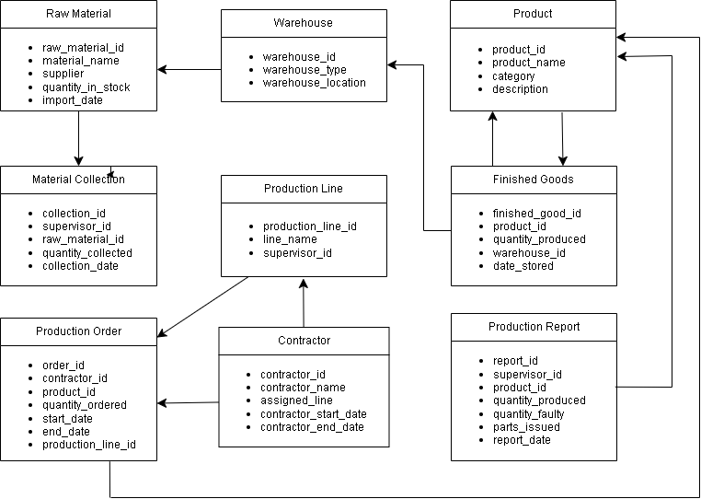

1. **Technology Stack:**

* **Frontend:**

HTML, CSS, JavaScript

* **Backend:**

Python (Flask)